26.80: a) (i) 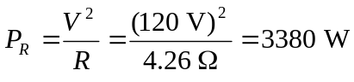 (ii) 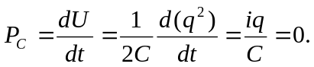
(iii) 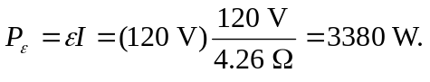
b) After a long time, 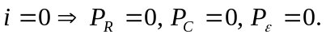

c)
